|  |  |
| --- | --- |
| Assignment No. | 3 |
| Team ID | PNT2022TMID05086 |
| Project Name: | Plasma Donor Application |
| Batch No. | B11-1A5E |

**MODULE 3 : Python Assignment**

**1.Consider a list (list=[]).You can perform the following commands**

* **insert i e: Insert integer at position.**
* **print: Print the list.**
* **remove e: Delete the first occurrence of integer**
* **append e: Insert integer at the end of the list.**
* **sort: Sort the list.**
* **pop: Pop the last element from the list.**
* **reverse: Reverse the list.**

list = []; list.insert(0,1) list.insert(1,2) list.insert(2,3) list.insert(3,10) list.insert(4,6) print(list)

list.remove(1) print("After deleting first occurance of list :") print(list)

list.append(0) print("After inserting integer at the end of the list :") print(list)

list.sort() print("After Sort :") print(list)

list.pop() print("After popping the last element from the list :") print(list)

list.reverse() print("After reversing the list :") print(list)

**OUTPUT**

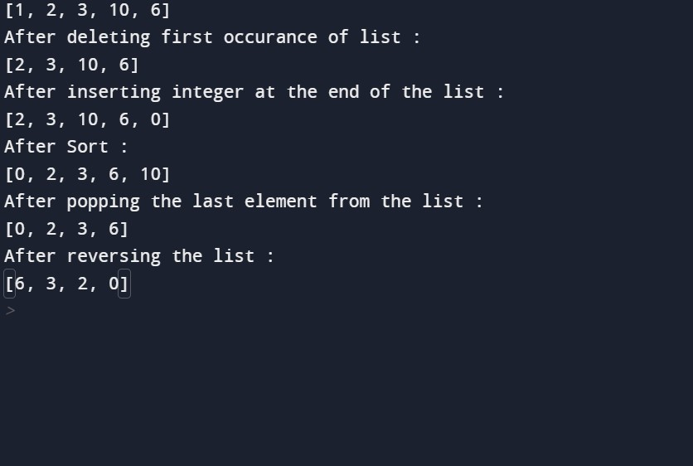

**2.Write a calculator program in python?**

# This function adds two numbers def add(x, y): return x + y

# This function subtracts two numbers def subtract(x, y): return x - y

# This function multiplies two numbers def multiply(x, y): return x * y

# This function divides two numbers def divide(x, y): return x / y print("Select operation.") print("1.Add") print("2.Subtract") print("3.Multiply") print("4.Divide") while True:

# take input from the user choice = input("Enter choice(1/2/3/4): ") # check if choice is one of the four options

if choice in ('1', '2', '3', '4'):

num1 = float(input("Enter first number: ")) num2 = float(input("Enter second number: "))

if choice == '1': print(num1, "+", num2, "=", add(num1, num2))

elif choice == '2':

print(num1, "-", num2, "=", subtract(num1, num2))

elif choice == '3': print(num1, "*", num2, "=", multiply(num1, num2))

elif choice == '4':

print(num1, "/", num2, "=", divide(num1, num2)) next_calculation = input("Let's do next calculation? (yes/no): ") if next_calculation == "no":

break

else:

print("Invalid Input")

**OUTPUT**

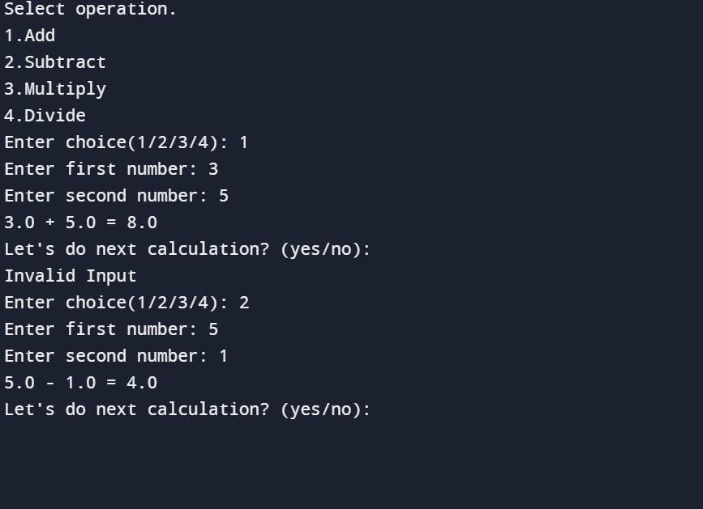

**2.Concatenate,reverse and slice a string in python?**

greeting = "Hello, World!"

#reverse the string print(greeting[::-1]) #slice the string print(greeting[:3]) #concatenate the string s1="Welcome" s2="People" s3=s1+s2 s4=s1+" "+s2 print(s3,s4)

**OUTPUT**

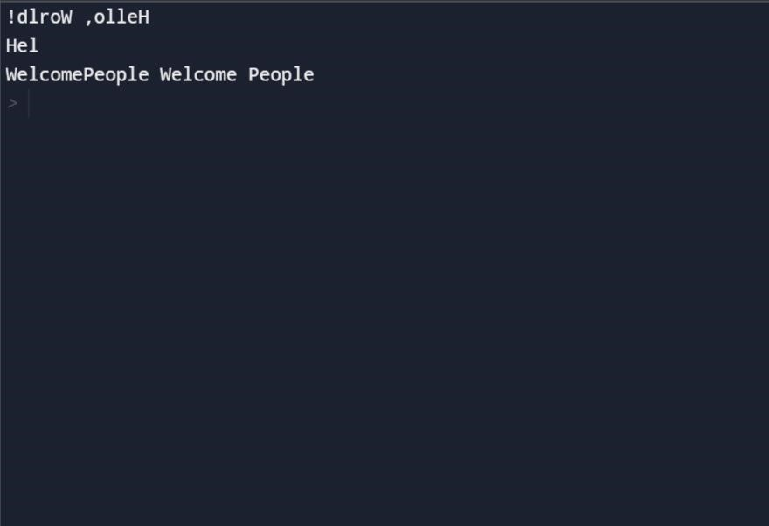

**3.Why is Python a popular programming language?**

In short, Python is a general-purpose language that is easy to learn and use. Due to its popularity, there is a big and helpful community. Also, Python is backed up by big companies like Google, Amazon, and Facebook. Python is suggested as the first programming language to learn due to its English-like syntax.

* Python is Easy to Learn and Use
* Python is Handy for Web Development Purposes
* The Language is Extensively used in Data Science
* Has Multiple Libraries and Frameworks
* Python can be used in ML tool
* Python for Academics
* Has a Highly Supportive Community
* Flexibility and Reliability
* Python Automates Tasks
* The First-choice Always

**4.What are the other frameworks that can be used with python?**

1. CubicWeb
2. Django
3. Giotto
4. Pylons Framework
5. Pyramid Framework
6. TurboGears
7. Web2Py

**Micro Frameworks:**

1. Bottle
2. CherryPy
3. Dash
4. Falcon
5. Flask
6. Hug
7. MorePath
8. Pycnic

**Asynchronous Frameworks:**

1. AIOHTTP
2. Growler
3. Uvloop
4. Sanic
5. Tornado

**6. Full form of WSGI ?**

Web Server Gateway Interface

1. **Create a bucket in IBM object storage**
2. **Upload 5 images to IBM object storage and make it public**

<html>

<head>

<title>Images from Object Storage</title>

<link rel="stylesheet" href="https://19itr091.s3.au-syd.cloud-objectstorage.appdomain.cloud/objectstorage_image.css">

<style> img{

width: 100px; height: 100px;

}

</style>

</head>

<body>

<div style="display: flex;width: 100vh;height: 100vh;justify-content: spacebetween;">

<div>

<img src="https://19itr091.s3.au-syd.cloud-objectstorage.appdomain.cloud/dog.jpg">

</div>

<div>

<img src="https://19itr091.s3.au-syd.cloud-objectstorage.appdomain.cloud/dog2.jpg">

</div>

<div>

<img src="https://19itr091.s3.au-syd.cloud-objectstorage.appdomain.cloud/dog3.jpg">

</div>

<div>

<img src="https://19itr091.s3.au-syd.cloud-objectstorage.appdomain.cloud/dog4.jpg">

</div>

<div>

<img src="https://19itr091.s3.au-syd.cloud-objectstorage.appdomain.cloud/dog5.jpg">

</div>

</div>

</body>

</html>

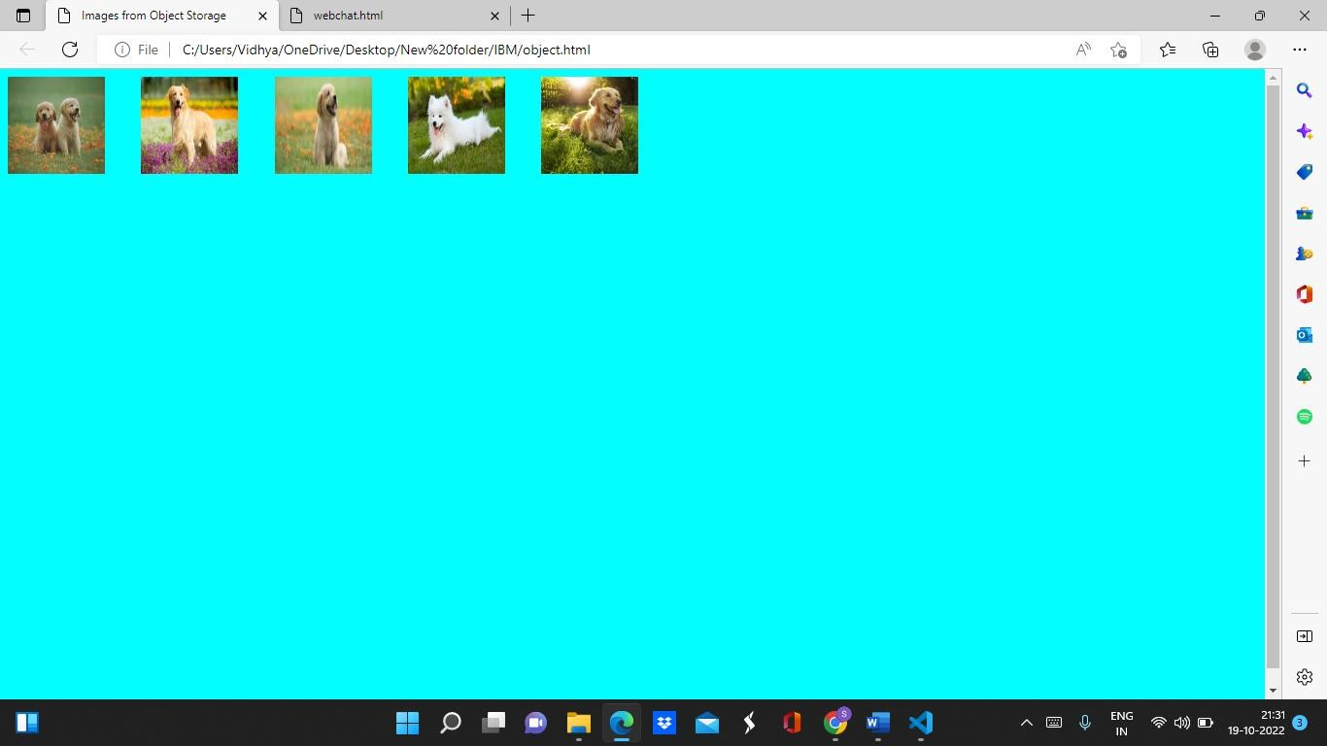

**4) Design a chatbot using IBM Watson assistant for hospital**

<html>

<head>

<style> .outside{ height: 100%; display: flex; flex-direction: column;

}

.header{ width: 100%; height: 15%; align-items: center; justify-content: center; display: flex;

}

.body{ width: 100%; height:75%;

background-image: linear-gradient(to right,violet,white);

}

</style>

</head>

<body>

<div class="outside">

<div class="header">

<div>

<p>HOTEL CHATBOT</p>

</div>

</div>

<div class="body">

</div>

</div>

</body> <script>

window.watsonAssistantChatOptions = {

integrationID: "125b5c0e-3055-4a53-a779-e55327d8130c", // The ID of this integration.

region: "au-syd", // The region your integration is hosted in.

serviceInstanceID: "0cc48fc3-d1eb-45cd-9391-84acd3a7f3fe", // The ID of your service instance.

onLoad: function(instance) { instance.render(); }

};

setTimeout(function(){

const t=document.createElement('script');

t.src="https://web-

chat.global.assistant.watson.appdomain.cloud/versions/" +

(window.watsonAssistantChatOptions.clientVersion || 'latest') +

"/WatsonAssistantChatEntry.js"; document.head.appendChild(t); });

</script>

</html>

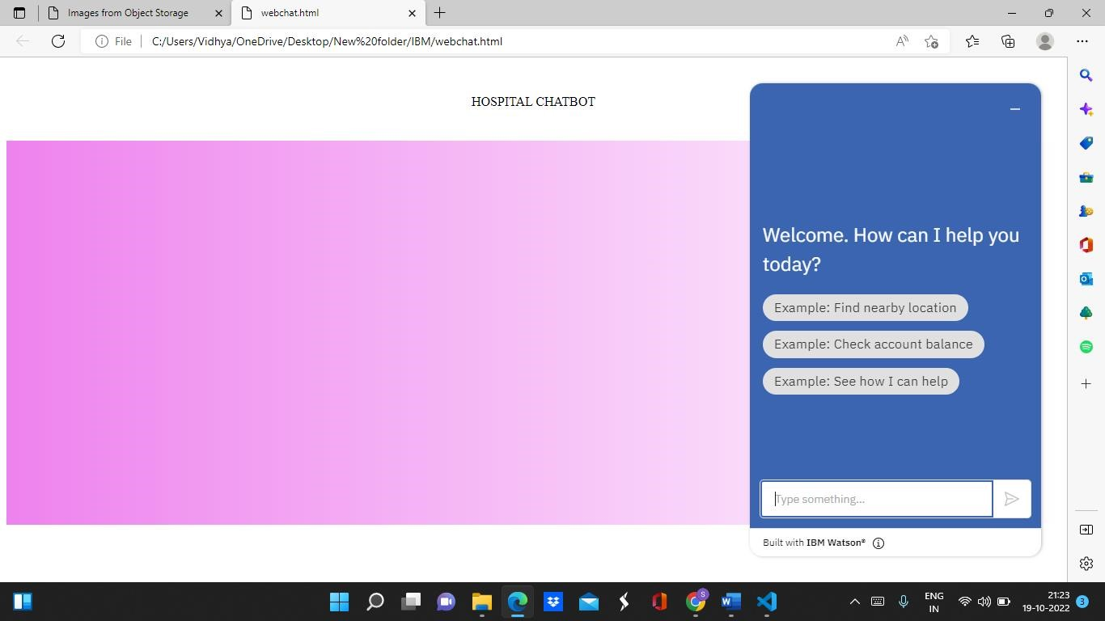

Webchat Link:

<https://web-chat.global.assistant.watson.appdomain.cloud/preview.html?backgroundImageURL=https%3A%2F%2Fau-syd.assistant.watson.cloud.ibm.com%2Fpublic%2Fimages%2Fupx-0cc48fc3-d1eb-45cd-9391-84acd3a7f3fe%3A%3Aedfcaf7c-e051-4684-8225-ab6ba2880316&integrationID=c28d8d6b-fe6b-4ad1-8f45-a72359da3030&region=au-syd&serviceInstanceID=0cc48fc3-d1eb-45cd-9391-84acd3a7f3fe>